Question Bank
Que. No. | Questions
Linear search with array, how many comparisons are needed in best case and Time complexity in best case for a successful search is_

a) 0,O(1)
b) 1, O(1)
c) n, O(n)
d) n/2,O(n)
Answer –b)
In linear search with list Time complexity in worst case for a Unsuccessful search is
a)1
b) n
c) n+1/2
d) n -1
Answer –b)
In linear search with array, how many comparisons are needed in worst case?
a) 0
b) 1
c) n
d) n/2
Answer- c )
Binary search is useful when there are large number of_______in array.

a) Arguments
b) values
c) Elements
d) all the above
Answer: c
In Binary search time complexity in best case for a successful search is __

a) 1
b) Log2N
c) log n+1
d) N log N
Answer: a)
In Binary search time complexity in worst case for a successful search is __

a) 1
b) log2 N
c) log n+1
d) N log N
Answer –b)
The number of comparisons for the Binary Search in ,best ,worst case is __

a) 1, n
b) 1, n+1
c) n,n
d) 1,n+1/2
Answer –d)
Which of the following is not the required condition for binary search algorithm?

a) The list must be sorted
b) There should be the direct access to the middle element in any sub list
c) There must be mechanism to delete and/or insert elements in list.
d) Number values should only be present
Answer – c)
Worst case and the best case complexity of quick sort is
a) O(n ^2) and O(n log n)
b) O(n log n) and O(n log n)
c) O(n^2) and O(n^2)
d) O(n log n) and O(n^2)
Answer – a)
Recurrence equal for worst case of quick sort?
a)t(n)=t(n-1)+c

b)t(n)=2t(n/2)+n

c)t(n)=t(n-1)+n

d)t(n)=2t(n/2)+c
Answer –c)
Which of the following is a stable sorting algorithm?
a) Merge sort
b) Typical in-place quick sort
c) Heap sort
d) Selection sort
Answer –a)
Consider the situation in which assignment operation is very costly. Which of the following sorting algorithm should be performed so that the number of assignment operations is minimized in general?

a) Insertion sort
b) Selection sort
c) bubble sort
d) None
Answer –b)
Which of the following sorting algorithm has the running time that is least dependent on the initial ordering of the input?
a) Insertion sort
b) Quick sort
c) Bubble sort
d) Selection sort

Answer – d)
The given array is arr = {1,2,3,4,5}. (bubble sort is implemented with a flag variable)The number of iterations in selection sort and bubble sort respectively are,
answer choices
a)5 and 4
b)1 and 4
c)0 and 4
d)4 and 1
Answer – d)
In bubble sort after each iteration :

a) at least one element is at its sorted position.

b) one less comparison is made in the next iteration.

c) Both a & b are true.

d) Neither a or b are true.

Answer – c)
Overall performance of the Quick sort is depends on the selection of

a) size of array
b) pivot element
c) sequence of values
d) none of the above
Answer –b)
Bubble sort sometimes referred to as _____________.

a) binding sort.
b) sinking sort.
c) skip sort.
d) none of these.
Answer –b)
Internal sorting algorithm is the__________
a) Algorithm that uses tape or disk during the sort
b) Algorithm that uses main memory during the sort
c) Algorithm that involves swapping
d) Algorithm that are considered ‘in place’
Answer: b)
Which of the following algorithm can you improve the best case efficiency in bubble sort? (The input is already sorted)
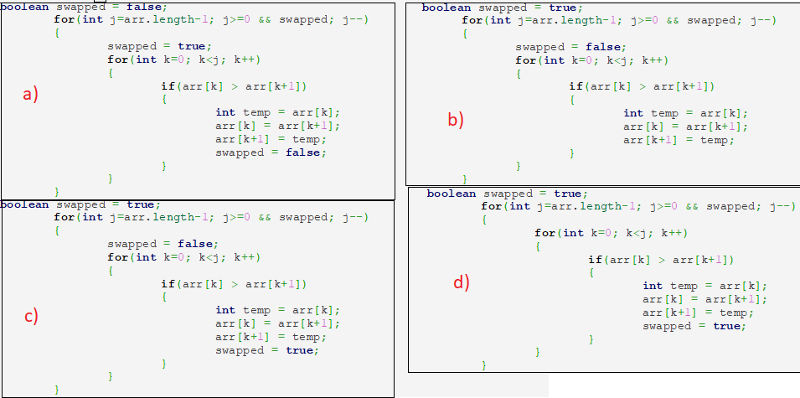
a) a
b) b
c) c
d) d
Answer: c)
What is the best case and worst-case complexity of ordered linear search?
a) O(nlogn), O(logn)
b) O(logn), O(nlogn)
c) O(n), O(1)
d) O(1), O(n)
Answer: d)
Choose the appropriate code that does binary search using recursion.
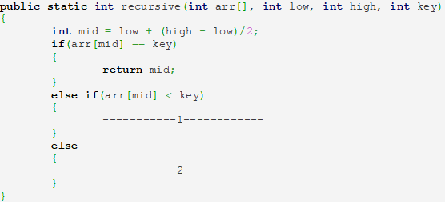
a) 1.return recursive(arr,mid+1,high,key); 2.return recursive(arr,low,mid-1,key);
b) 1. return recursive(arr,mid-1,high,key); 2. return recursive(arr,low,mid+1,key);
c) 1. return recursive(arr,mid,high,key); 2. return recursive(arr,low,mid-1,key);
d) 1.return recursive(arr,mid,high-1,key); 2. return
recursive(arr,low,mid-1,key);
Answer: a)
Given an array arr = {45,77,89,90,94,99,100} and key = 100; What are the mid values(corresponding array elements) generated in the first and second iterations?
a) 90 and 99
b) 90 and 100
c) 89 and 94
d) 94 and 99
Answer: a)

Which of the following sorting algorithm is not stable?
a) Bubble Sort
b) Insertion Sort
c) Merge Sort
d) Quick Sort
Answer: d)

What is the running time of an insertion sort algorithm if the input is pre-sorted?
a) O(N2)
b) O(N log N)
c) O(N)
d) O(M log N)
Answer: c)

Merge sort uses which of the following technique to implement sorting?
a) backtracking
b) greedy algorithm
c) divide and conquer
d) dynamic programming
Answer: c)
Choose the correct option for the following statements.
1. the worst-case time complexity of merge sort is O( n log n) and Quick Sort is O(n^2)
2.the worst-case time complexity of merge sort is O(n^2) and Quick Sort is O( n log n)
3.the worst-case time complexity of Quicksort is O(n^2) and it is stable
4.the best-case complexity of quick and merge sort is O( n log n)
a) 1 and 3 is correct
b) 2 and 3 is correct
c) 1 and 4 is correct
d) 3 and 4 is correct
Answer: c)
Apply Quick sort on a given sequence 7 11 14 6 9 4 3 12. What is the sequence after first phase, pivot is first element?
a) 6 4 3 7 11 9 14 12
b) 6 3 4 7 9 14 11 12
c) 7 6 14 11 9 4 3 12
d) 7 6 4 3 9 14 11 12
Answer: b)
Consider a Quicksort implementation that is supposed to sort an array in ascending order. After the first partition step has been completed, the contents of the array are in the following order:

3 9 1 14 17 24 22 20

Which of the following statements is correct about the partition step?
a) The pivot could have been either 14 or 17
b) The pivot could have been 14, but could not have been 17
c) The pivot could have been 17, but could not have been 14
d) Neither 14 nor 17 could have been the pivot

Answer- a)

Which of the following statement is not true about insertion sort?

a) Exhibits the worst case performance when the initial array is sorted in reverse order.

b) - Worst case and average case performance is Ο(n2)

c)- Can be compared to the way a card player arranges his card from a card deck.

d) - None of the above
Answer –d)
Match the following −

(1) Bubble Sort (A) O (log n)
(2) Shell Sort (B) Ο(n2)
(3) Selection Sort (C) Ο(n log n)
(4) Binary search (D) Ο(n)
a) 1→ A, 2 →B, 3 → C, 4 → D

b) 1 → B, 2 → C, 3 → D, 4→ A

c) 1→ D, 2 → C, 3 → B, 4→ A

d) 1 → B, 2 → D, 3 → C ,4→ A
Answer – c)
____________ sorting algorithm is frequently used when n is small where n is total number of elements.
a) bubble Sort
b) quick Sort
c) Heap Sort
d) Merge Sort
Answer –a)
_____________ order is the best possible for array sorting algorithm which sorts n item.
a) O(n^2)
b) O(n log n)
c) O( n+ log n)
d) O( n)
answer – d)
Partition and exchange sort is _________________ .
a) Merge sort
b) Quick Sort
c) Heap Sort
d) bubble Sort
Answer –b)
for i = 1 to n - 1
/* set current element as minimum*/
min = i

/* check the element to be minimum */

for j = i+1 to n
if list[j] < list[min] then
min = j;
end if
end for

/* swap the minimum element with the current element*/
if indexMin != i then
swap list[min] and list[i]
end if
end for
Above given code snippet is part of ------- code /Algorithm
a) bubble sort
b) selection sort
c) bucket Sort
d) shell sort
Answer –b)

while x not found
if upperBound < lowerBound
EXIT: x does not exists.

set midPoint = lowerBound + ( upperBound - lowerBound ) / 2

if A[midPoint] < x
set lowerBound = midPoint + 1

if A[midPoint] > x
set upperBound = midPoint - 1

if A[midPoint] = x
EXIT: x found at location midPoint
end while

Above code snippet is the part of ----- code /algorithm

a) Linear search
b) Quick sort
c) Recursive Binary Search
d) Non Recursive Binary Search

Answer -d)
Suppose the first Fibonacci number is 0 and the second is 1. What is the sixth Fibonacci number?
a) 5
b) 6
c) 7
d) 8
Answer –a)
Which of the following is not a Fibonacci number?
a) 8
b) 21
c) 55
d) 14
Answer –d)
The running time of the following sorting algorithm depends on whether the partitioning is balanced or unbalanced.
a) Insertion sort
b) Selection sort
c) Quick sort
d) Merge sort
Answer - c)
A Stable sorting algorithm is one :

a) its time complexity is constant irrespective of the nature of input
b) preserves the original order of records with equal keys
c) its space complexity is constant irrespective of the nature of input
d) it sorts any volume of data in a constant time
Answer b)
Which is the best possible choice to select a pivot / partitioning element in quick sort is
a) First element of the list
b) Last element of the list
c) Randomly chosen element of the list
d)Median of the list
Answer – d)
The average case time complexity of binary search using recursion?
a) O(nlogn)
b) O(logn)
c) O(n)
d) O(n^2)
Answer –b)
The following formula will produce

Fn = Fn-1 + Fn-2
a) Armstrong Number

b) Fibonacci Series

c) Euler Number

d) Prime Number

Answer –d)
The following sorting algorithms maintain two sub-lists, one sorted and one to be sorted −
a)Selection Sort
b)Insertion Sort
c)Merge Sort
d)both A & B
Answer –d)
The average searching time for Fibonacci search is__________.
a) N(log N)
b) S(log N)
c) O(log N)
d )None of the above
Which of the following is good for sorting arrays having less than 100 elements?
a) Quick Sort
b) Selection Sort
c) Merge Sort
d) Insertion Sort
Answer ->d)
The worst case time complexity of insertion sort is O(n2). What will be the worst case time complexity of insertion sort if the correct position for inserting element is calculated using binary search?
a) O(nlogn)
b) O(n2)
c) O(n)
d) O(logn)
Answer -b)

What will be the number of passes to sort the elements using insertion sort?
14, 12, 16, 6, 3, 10

A )6
b) 5
c) 7
d) 1
Answer –b)

For the following question, how will the array elements look like after second pass?
34, 8, 64, 51, 32, 21

a) 8, 21, 32, 34, 51, 64
b) 8, 32, 34, 51, 64, 21
c) 8, 34, 51, 64, 32, 21
d)8, 34, 64, 51, 32, 21
Answer – d)
Which of the following options contain the correct feature of an insertion sort algorithm?
a) anti-adaptive
b) dependable
c) stable, not in-place
d) stable, adaptive
Answer –d)
For the best case input, the running time of an insertion sort algorithm is?
a) Linear
b)Binary
c) Quadratic
d) Depends on the input
Answer –a)
Which algorithmic technique does Fibonacci search use?
a) Brute force
b) Divide and Conquer
c) Greedy Technique
d) Backtracking
Answer –b)
What is the time complexity of Fibonacci Search?
a) O(logn)
b) O(n)
c) O(n²)
d) O(nlogn)
Answer –a)
Which of the following is not an advantage of Fibonacci Search?
a) When the element being searched for has a non uniform access storage
b) complexity is logn
c) Can be used for large arrays which do not fit in the CPU cache or in the RAM
d) It can be applied efficiently on unsorted arrays
Answer –d)
Consider the following iterative implementation to find the nth fibonacci number?
int main()
{
int n = 10,i;
if(n == 1)
printf("0");
else if(n == 2)
printf("1");
else
{
int a = 0, b = 1, c;
for(i = 3; i <= n; i++)
{
c = a + b;
________;
________;
}
printf("%d",c);
}
return 0;
}

Which of the following lines should be added to complete the abovecode?
a)c = b;b = a
b) a = b; b = c
c) b = c;a = b
d) a = b;b = a
Answer –b
Consider the following recursive implementation to find the nth fibonacci number:
int fibo(int n)
{
if(n == 1)
return 0;
else if(n == 2)
return 1;
return ________;
}
int main()
{
int n = 5;
int ans = fibo(n);
printf("%d",ans);
return 0;
}
Which of the following lines should be inserted to complete the above code?
a) fibo(n – 1)
b) fibo(n – 1) + fibo(n – 2)
c) fibo(n) + fibo(n – 1)
d) fibo(n – 2) + fibo(n +1)
Answer –b

What is the time complexity of the following recursive implementation to find the nth fibonacci number?
int fibo(int n)
{
if(n == 1)
return 0;
else if(n == 2)
return 1;
return fibo(n - 1) + fibo(n - 2);
}
int main()
{
int n = 5;
int ans = fibo(n);
printf("%d",ans);
return 0;
}
a) O(1)
b) O(2*n)
c) O(n²)
d) O(2^{n})
Answer –d

How many times will the function fibo() be called when the following code is executed?
int fibo(int n)
{
if(n == 1)
return 0;
else if(n == 2)
return 1;
return fibo(n - 1) + fibo(n - 2);
}
int main()
{
int n = 5;
int ans = fibo(n);
printf("%d",ans);
return 0;
}
a) 5
b) 6
c) 8
d) 9
Answer –d

What is the output of the following code?
int fibo(int n)
{
if(n == 1)
return 0;
else if(n == 2)
return 1;
return fibo(n - 1) + fibo(n - 2);
}
int main()
{
int n = 10;
int ans = fibo(n);
printf("%d",ans);
return 0;
}
- 21
b) 34
c) 55
d) 13
Answer –b

What is an external sorting algorithm?
a). Algorithm that uses tape or disk during the sort
b). Algorithm that uses main memory during the sort
c). Algorithm that involves swapping
d). Algorithm that are considered ‘in place’
Answer –a

Which of the following is not a stable sorting algorithm?
a) Insertion sort
b). Selection sort
c) Bubble sort
d) Merge sort
Answer –b

Which of the following is not an in-place sorting algorithm?
a)Selection sort
b)Heap sort
c) Quick sort
d) Merge sort
Answer –d

What is the auxiliary space complexity of merge sort?
a) O(1)
b) O(log n)
c) O(n)
d) O(n log n)
Answer –c

What is the average case time complexity of merge sort?
a) O(n log n)
b) O(n²)
c) O(n² log n)
d) O(n log n²)
Answer –a

Recurrence equation for best case of Merge sort
a)T(n) = 2T(n/2) + cn
b)T(n) = T(n/2) + cn
c) T(n) = 2T(n/2) + c
d) T(n) = T(n-1) + n
Answer –a

Solve the recurrence equation
T(n) = 2T(n/2) + cn
a) n²logn
b) n²
c) nlogn
d)n³
Answer –c

What is the other name for a shell sort algorithm?
a) Diminishing increment sort
b) Diminishing decrement sort
c) Insertion sort
d) Selection sort
Answer –a

The worst case running time of shell sort, using Shell’s increments is?
a) O(N)
b) O(N log N)
c) O(log N)
d) O(N²)
Answer –d

Shell sort algorithm is an example of?
a) External sorting
b) Internal sorting
c) In-place sorting
d) Bottom-up sorting
Answer –b

Why is Shell sort called as a generalization of Insertion sort?
a) Shell sort allows an exchange of far items whereas insertion sort moves elements by one position
b) Improved lower bound analysis
c) Insertion is more efficient than any other algorithms
d) Shell sort performs internal sorting
Answer –a

Which of the following statements is the basic for loop for a shell sort algorithm?
a) for(increment=N/2;increment>0;increment/=2)
b) for(i=1;i<n;i++)
c) for(i=n/2;i>=0;i- -)
d) for(i=0;i< n;i++;numelements- -)
Answer –a

-----------******-----------

